Step 1: After decompiling Ghidra, we check our Decompile, click on the first parameter because in the __libc_start_main function, change it to main, then click on it, scroll down to the end and we will see.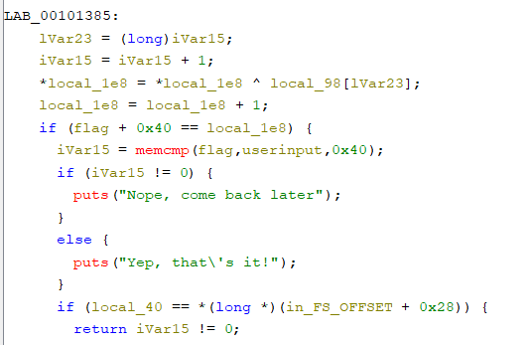

Here I have edited the striped functions into the names flag and userinput for easier checking.

Step 2: We see the memcmp function is used to check the flag, why do I set it to flag or userinput then I check its data in the main function.

Step 3: So we know where the flag is -> it will be in memcmp in the first parameter will be rdi.

Part2: We switch to GDB to check the flag.

Step 1:

Run the command

db ./not-crypto

set pagination off

start

break memcmp@plt

run

x/64s $rdi

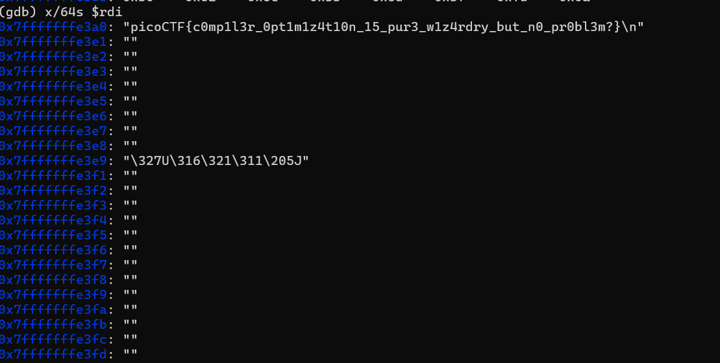

And here is the flag